Assignment No: 09
Deploy a project from GitHub to EC2.
Solution:
Step 1:
Upload required files to GitHub
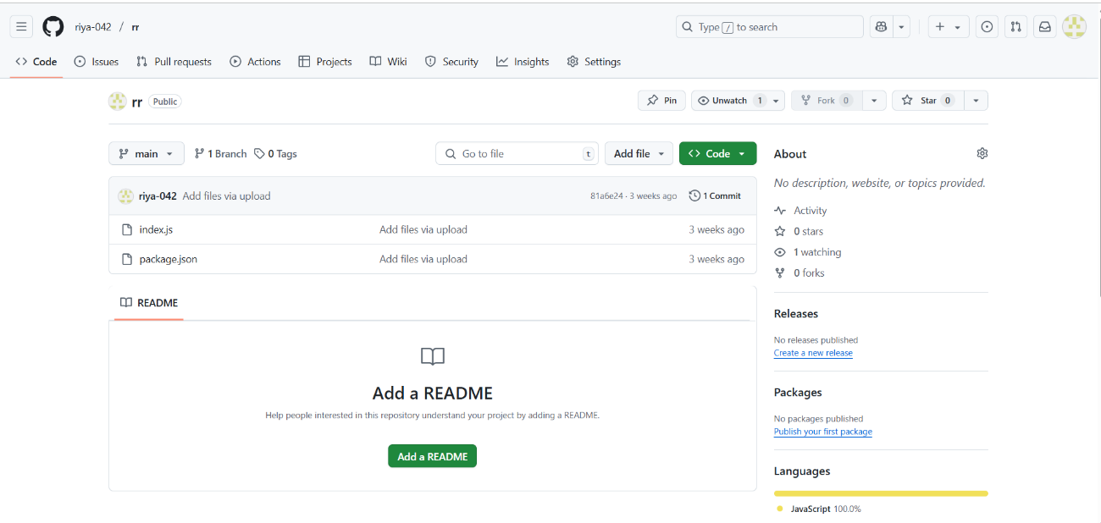
Step 2:
Log into AWS and open EC2. Click on launch instance. Give a name to the instance and select the operating system as Ubuntu.
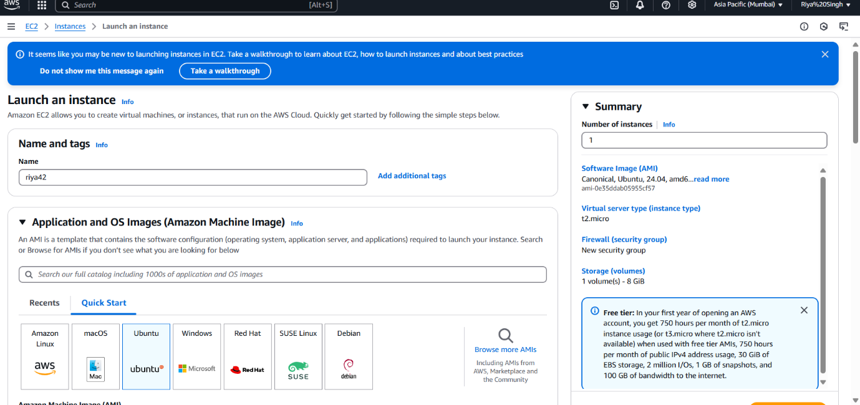
Step 3: Create Key Pair.
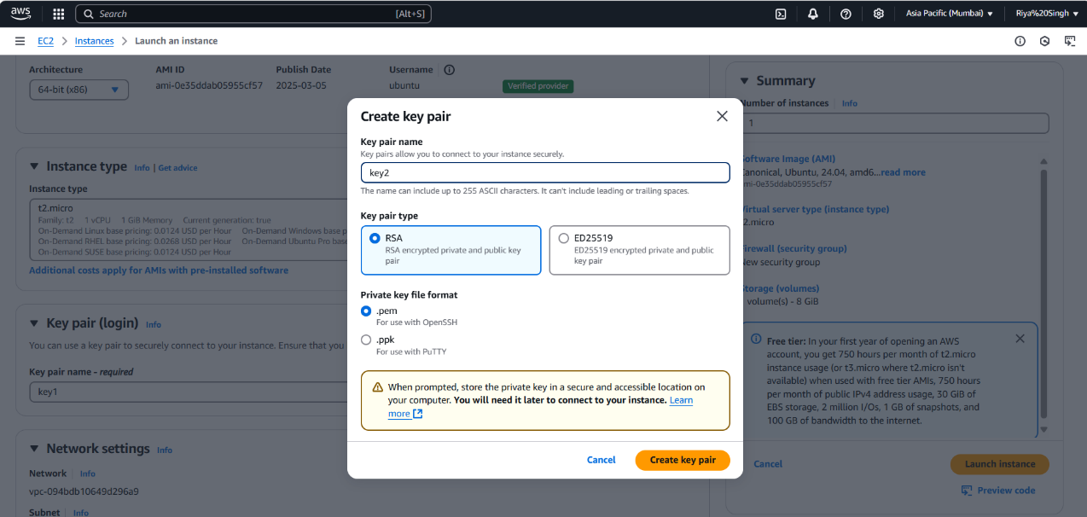
Step 4:
Check the 3 boxes to allow SSH, HTTP and HTTPS traffics and click launch instance.
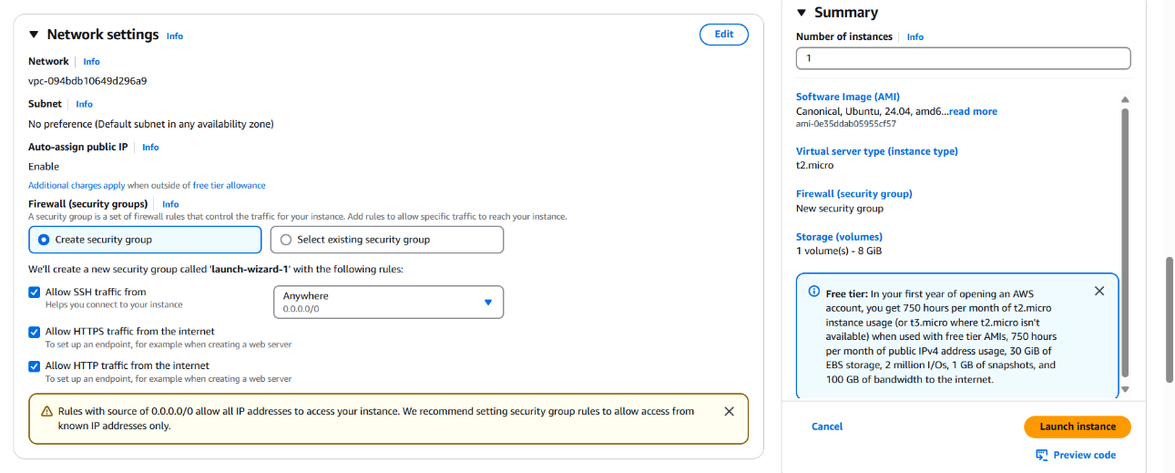
Step 5: Open instances and click of the instance Id of the instance. Copy the IPv4 address.
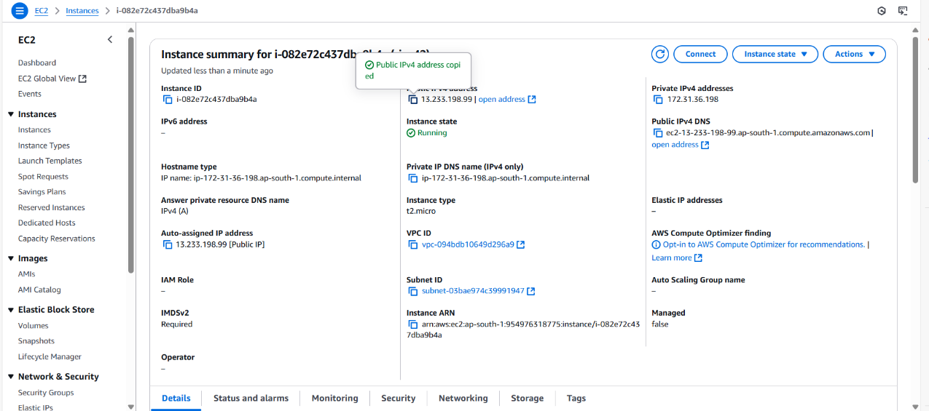
Step 6:
Open Bitvise SSH Client and paste the IP address in host and set up authentication using the key pair then login and after logging in open new terminal window.
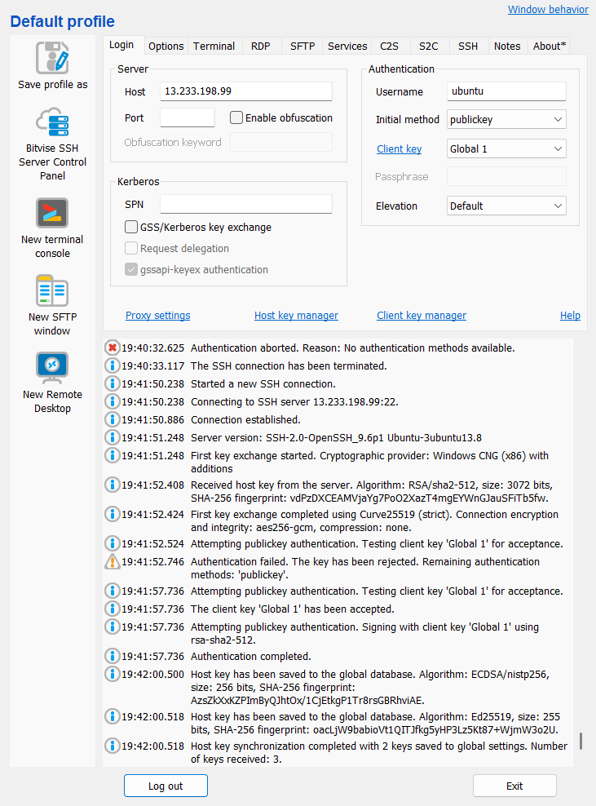
Step 7:
Then Execute command sudo apt-get update and sudo apt-get upgrade in the Bitvise SSH Client Terminal.
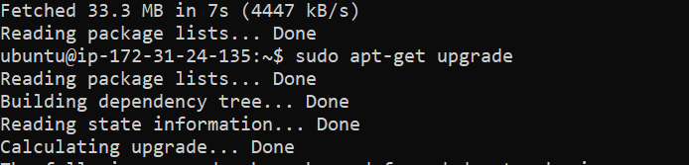
Step 8:
Now Execute sudo apt -get install nginx Cmd for setting up the web server.
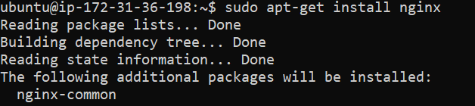
Step 9:
After that, then open the directory that is cloned using command cd name of the directory. Then install NodeJS using commands curl:
https://deb.nodesource.com/setup_18.x | sudo -E bash – and sudo apt-get install nodejs.
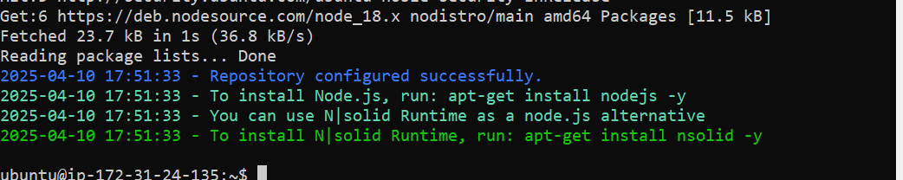
Step 10: Now clone the GitHub repository from GitHub using command git clone paste the link of the repository
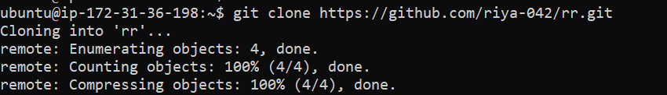
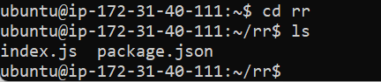
Step 11: After installing nodejs use npm install command to install required dependencies.
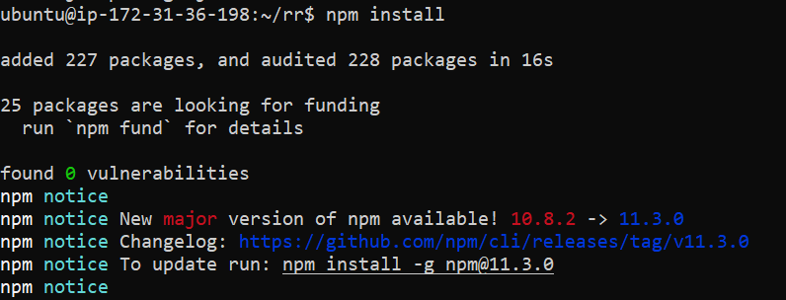
Step 12: Now open AWS and open the current instance then scroll down and go to security Section.
Then click on the link in security groups then click on edit inbound rules.
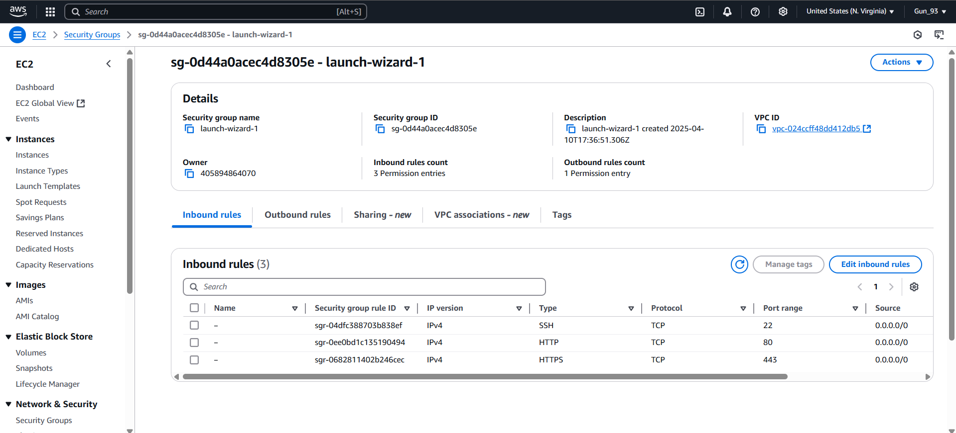
Step 13: Click on add rule and select the type of new rule custom TCP Port range 4000 source 0.0.0.0 or anywhere then click on save rule.

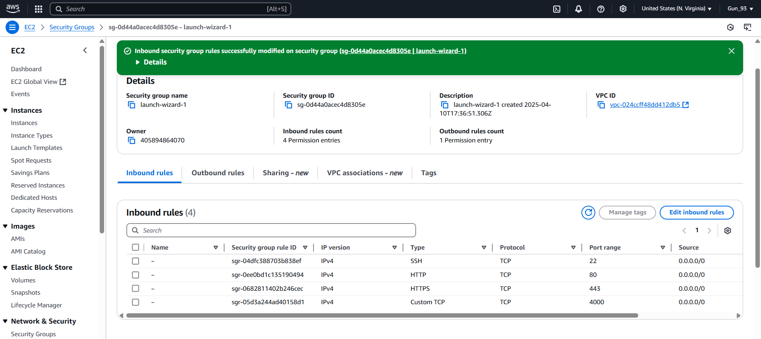
Step 14: Open the Bitvise SSH Client terminal console and start the server using command node index.js
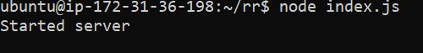

Step 15: Now copy the IPv4 address of the instance and paste it on web browser.
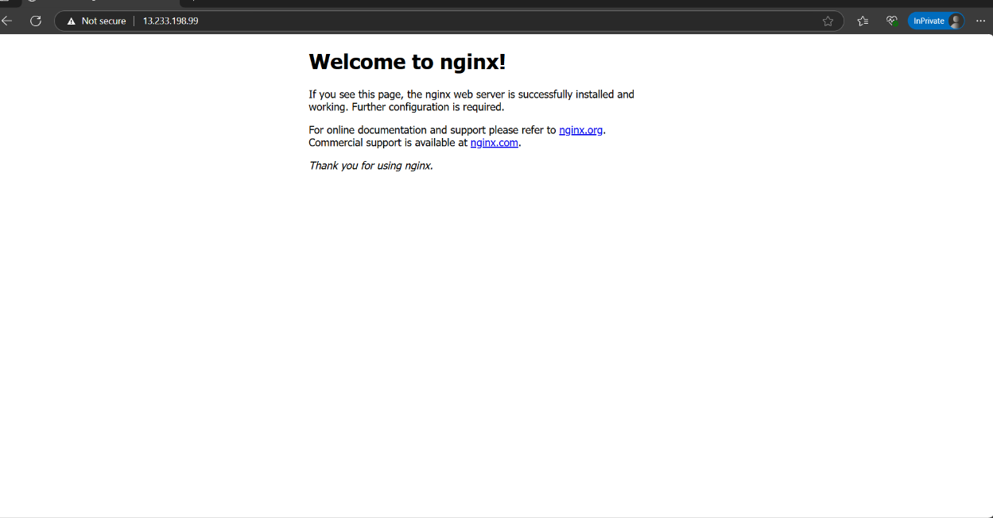
Step 16:
Then, put the port like this IP address


